Date:20-12-23

PYTHON ASSESSMENT

Question1:

explain Python Module with examples

sol:

Here, two user defined modules are created and executed. First module is used for calculating and the second module is used to calculate the railway and an inbuilt module is also used as an example.

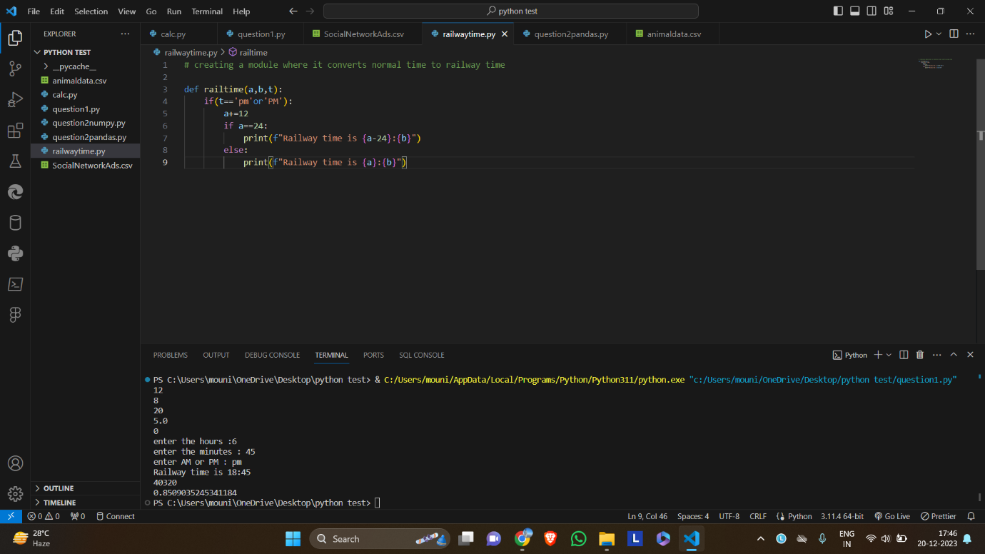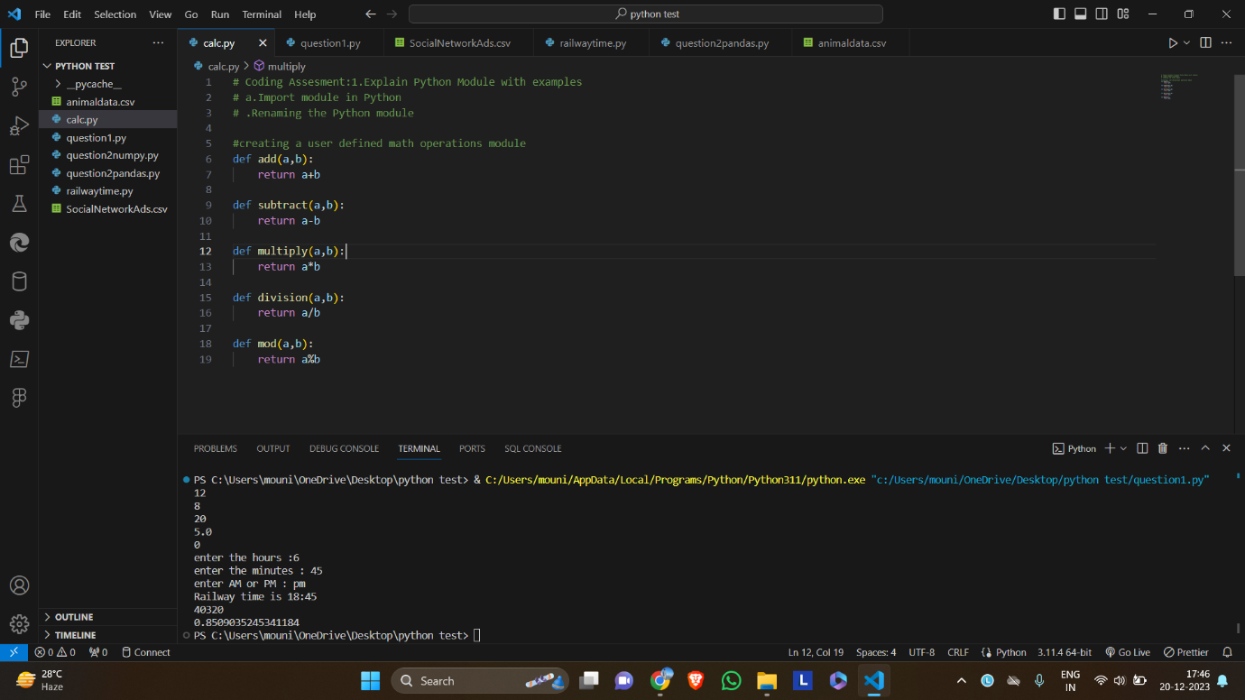

These modules are imported in another file and executed. And also used rename module.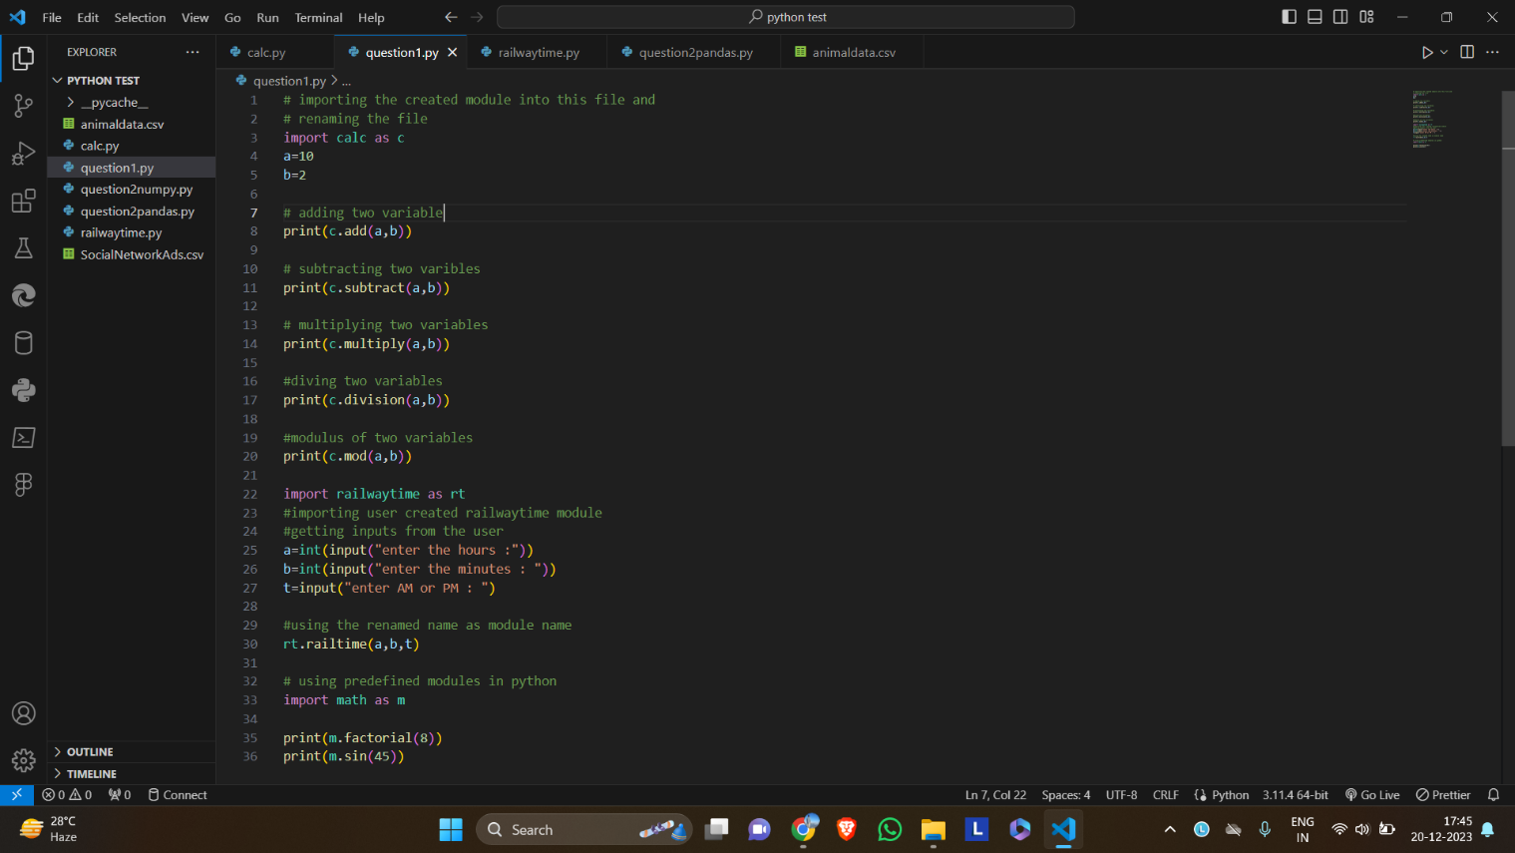

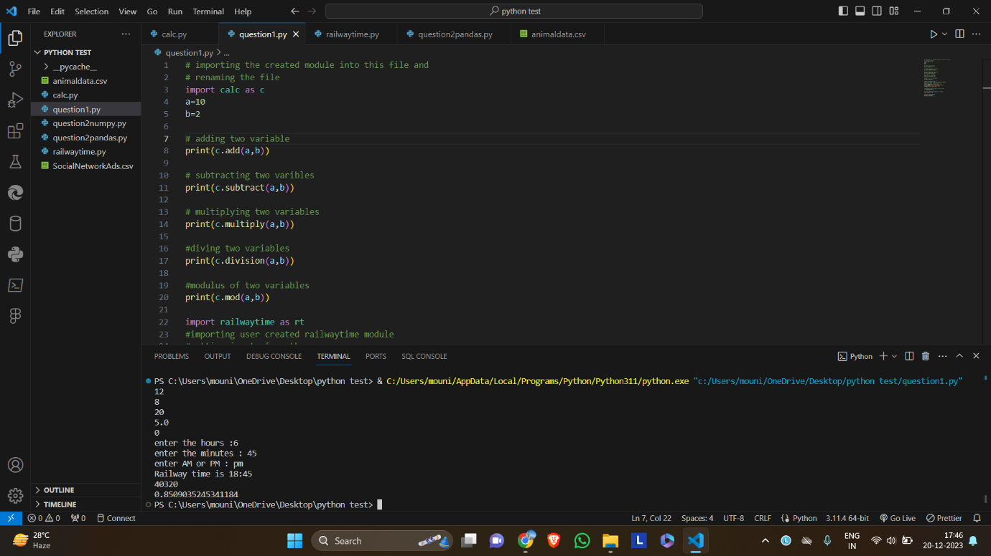

Question2:

1. Pandas with example

Here we will see how to import pandas module, how to create a data frame, how to write and read csv using pandas etc.

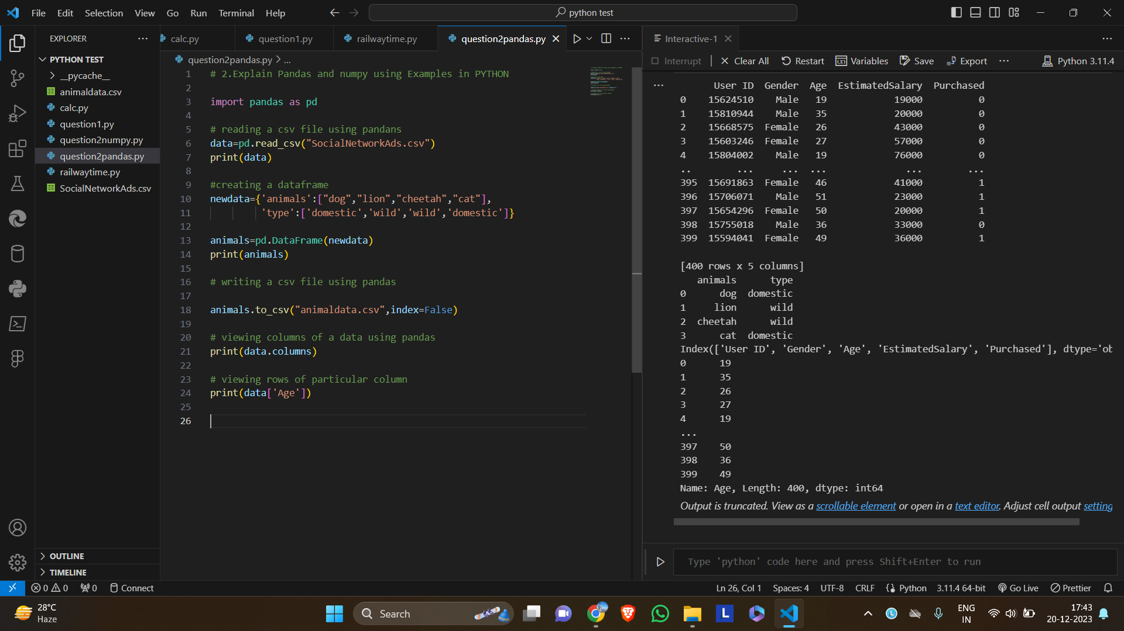

Next screenshot will show the csv file created using pandas.

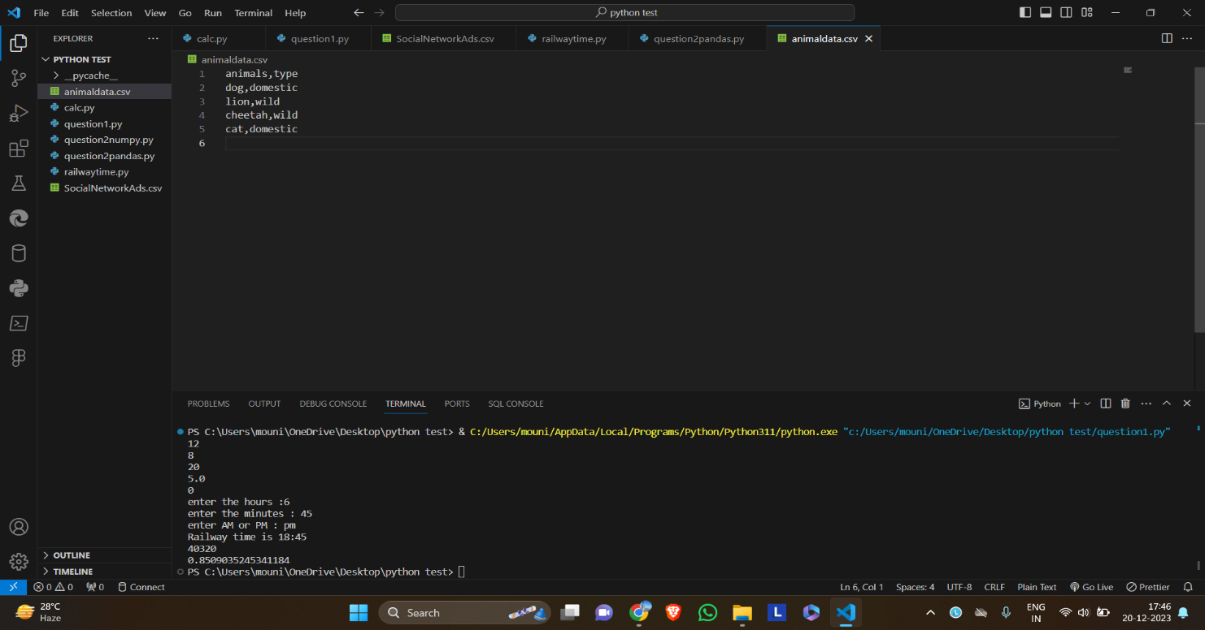

1. NumPy with examples

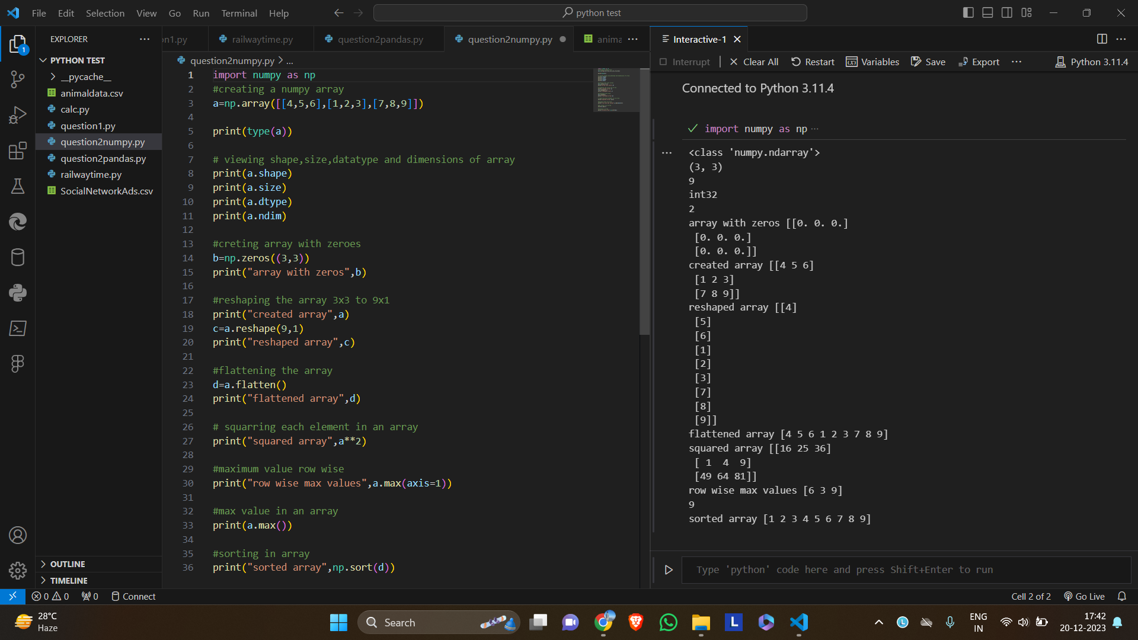

Here, it shown hoe to create a numpy array , how to view its shape ,size and dimensions. Also used array functions like modifying elemnts, reshaping the array, max value etc.